**Name**: Pravallika Sheshabhatter

**Batch code:** [LISUM21](https://canvas.instructure.com/courses/6781462)

**Submitted to: https://github.com/sbpravallika/week4**

**Created app on Heroku**

**Connected to GITHUB with the week4 flask deployment.**

**Deploy the branch manually:**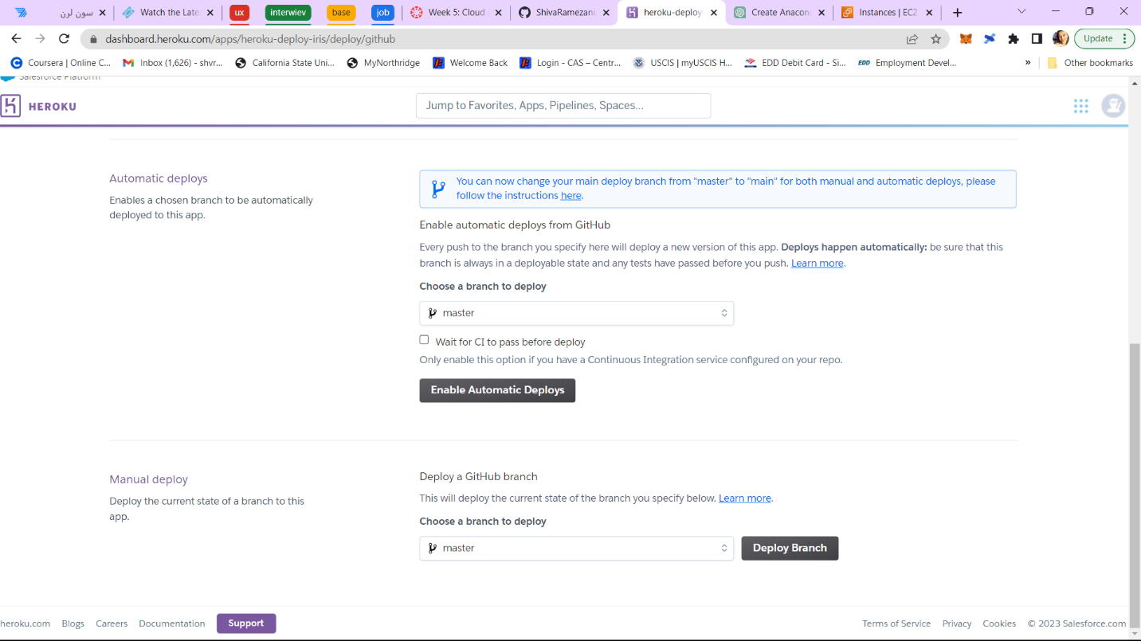

**App Deployed on Heroku :**

**After viewing the deployed URL am getting the below error I tried to fix the error and also contacted the Heroku support as well . Tried so many attempts but I was unable to solve them.**

|  |
| --- |
| **I understand the deployment process in cloud I used different deployment platforms to get the result with the url. I tried AWS, GCP as well but am getting the same error . I tried to resolve it tried so many ways, but I am unable to fix the error.** |